Final Project



**PROJECT**

TOPIC

Sales Report of S & K Company

FROM

Karima Khanom

Student ID: 03

Batch: Office69

TO

**Md Mahbub E Noor**

Lecturer

**DEPARTMENT OF COMPUTER SCIENCE & ENGINEERING**

Date: 17.02.2025

Table of Contents

1 Executive Summary 2

2 Products and Services Offered by XYZ Company 3

2.1 Products 3

2.1.1 Consumer Electronics 3

2.1.2 Semiconductors and Components 6

2.2 Services 7

3 XYZ Company Electronics Future Business Plans 9

3.1 Primary goal 11

3.2 Intermediate goal 12

3.3 Long-term goal 12

4 Sales and cost statistics 13

4.1 Region wise Total sales 13

4.2 Product wise Total Sales 14

4.3 Employees Sales and Salary 15

4.4 Report of first quarter of 2024 16

4.5 Yearly Net Profit of every month 17

5 Analysis of yearly financial report 19

6 Conclusion 20

# Executive Summary

XYZ Company Electronics, a flagship subsidiary of the XYZ Company Group, is a global leader in technology and consumer electronics. Established in 1969, the company has become synonymous with innovation, offering a diverse range of products that include smartphones, televisions, home appliances, semiconductors, and displays.

XYZ Company is renowned for its Galaxy series of smartphones and tablets, QLED and OLED televisions, and advanced home appliances that integrate smart technologies. The company's semiconductor division is a major supplier of memory chips, processors, and display panels, serving both its own products and other leading tech brands.

Through groundbreaking innovations like foldable smartphones, AI-powered appliances, and its Internet of Things (IoT) platform, Smart Things, XYZ Company continues to shape the future of digital connectivity. With a global presence in over 80 countries, XYZ Company Electronics is a driving force in the electronics industry, committed to sustainability and cutting-edge technology.

# Products and Services Offered by S & K Company

S & k Company, a technology leader, offers a wide range of innovative products and services across various sectors, catering to both consumer and business markets.

## Products

### Consumer Electronics

1. Smartphones:

* [Galaxy Series](https://www.samsung.com/bd/smartphones/) (e.g., Galaxy S, Galaxy Z Fold, Galaxy A).
* Known for cutting-edge technology, advanced cameras, and sleek designs.

1. Wearable Devices:

* Smart watches ([Galaxy Watch series](https://www.samsung.com/levant/watches/all-watches/)).
* Wireless ear buds ([Galaxy Buds series](https://en.wikipedia.org/wiki/Samsung_Galaxy_Buds_series)).

1. Televisions:

* QLED, OLED, and Neo QLED TVs featuring 4K and 8K resolutions.
* The Frame and The Serif series, blending technology with home decor.

1. [Home Appliances](https://transcomdigital.com/samsung?gad_source=1&gclid=CjwKCAiAxqC6BhBcEiwAlXp45wkMHh_dBwcZucICykelcMcWCgWTiwN5iVt4wyIPEktx2phPsB3vWRoCLuwQAvD_BwE):

* Refrigerators, washing machines, air conditioners, and vacuum cleaners with smart features.

1. Tablets:

* [Galaxy Tab series](https://www.samsung.com/bd/tablets/?product1=sm-p615nzaabkd&product2=sm-t225nzaabkd&product3=) for productivity, creativity, and entertainment.

1. Laptops and Monitors:

* Galaxy Book series and high-performance monitors, including gaming and ultra-wide displays.

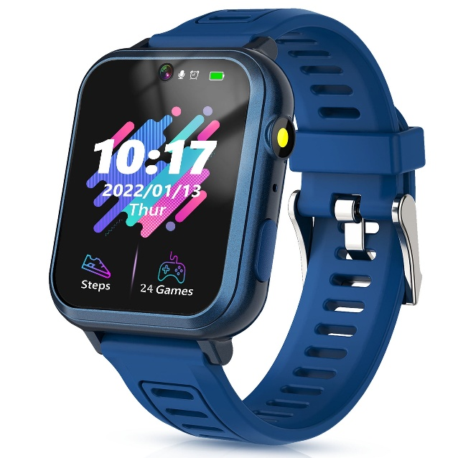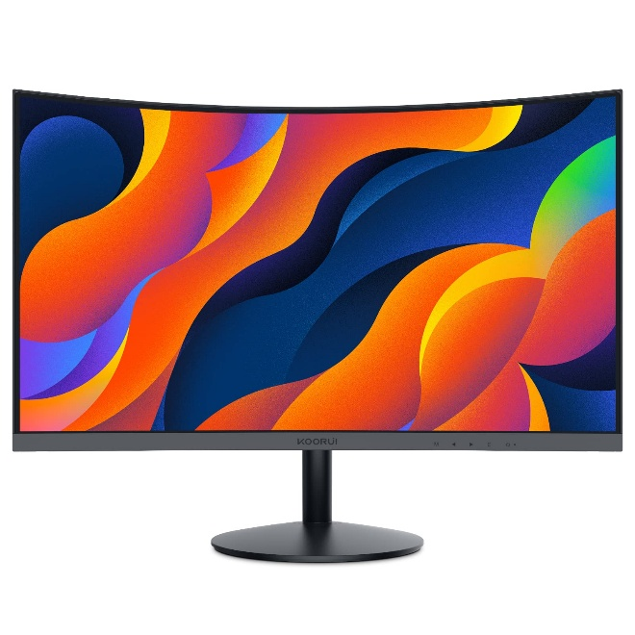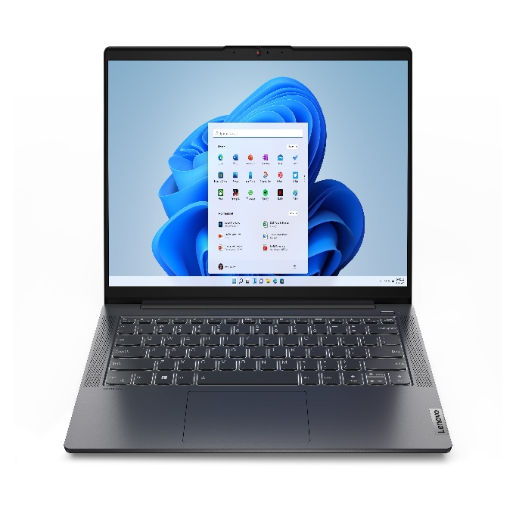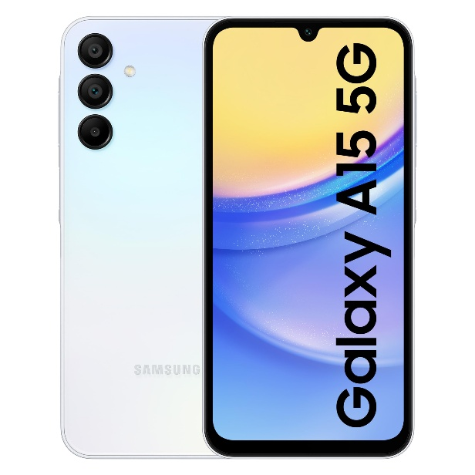

**Monitor**

**Smart Watch**

**Galaxy Smartphone**

Laptop

Laptop

Laptop

### Semiconductors and Components

1. Memory Chips:

* DRAM, SSDs, and NAND flash storage for personal and enterprise applications.

2. Processors:

* [Exynos](https://en.wikipedia.org/wiki/Exynos) chipsets for smartphones and other devices.

3. Displays:

* AMOLED and Super AMOLED screens for devices, and display panels for other manufacturers.

## Services

1. [S & K Company Pay](https://pay.google.com/about/):

* A secure and convenient mobile payment service.

2. XYZ Company Health:

* A health and wellness platform that integrates with wearable devices.

3. Bixby:

* An AI-powered virtual assistant for smart device control and voice commands.

4. Smart Things:

* An IoT platform for managing connected devices in a smart home ecosystem.

5. XYZ Company Knox:

* A security platform for safeguarding data on XYZ Company devices, particularly for businesses.

6.  [S & K Company Care+:](https://www.samsung.com/bd/support/contact/)

* Extended warranty and protection services for XYZ Company products.

7. Enterprise Solutions:

* Business solutions including mobile device management, display signage, and enterprise hardware.

With a focus on innovation, XYZ Company consistently expands its portfolio, maintaining its position as a global leader in technology and electronics.

# S & K Company Electronics Future Business Plans

XYZ Company Electronics aims to solidify its position as a global technology leader by focusing on innovation, sustainability, and expansion into emerging technologies. The company's future business plans emphasize growth in key areas, including advanced technologies, environmental responsibility, and strategic partnerships.

XYZ Company has announced plans to invest over $200 billion in the coming years in semiconductor, AI, and green technology advancements, aiming to drive long-term growth and maintain its competitive edge in the global market.

By combining technological leadership, sustainability, and a forward-thinking approach, XYZ Company Electronics aims to shape the future of innovation while addressing the needs of consumers and businesses worldwide.

**Expansion AI**

**Primary focus**

**Flexible Display**

Emerging Technologies

Sustainability

**Global Expansion**

**Consumer Centric Solution**

**Leadership in**

**5G & 6G**

**Semiconductor Technology**

**Intermediate**

**Long-Term**

## Primary goal

1. Innovation in Semiconductor Technology

* XYZ Company plans to maintain its leadership in the semiconductor industry by investing heavily in advanced manufacturing processes, including 3nm and 2nm chip technologies.
* Expansion of its foundry services to support global demand for AI, automotive, and IoT applications.

2. Leadership in 5G and 6G Networks

* Strengthening its position in the 5G market with infrastructure and devices while investing in research for 6G technology to lead the next wave of telecommunications.

3. Expansion of AI and IoT Ecosystems

* Enhancing the Smart Things platform to integrate more connected devices, promoting seamless smart home and workplace environments.
* Developing AI-driven solutions for consumer electronics and enterprise applications.

4. Growth in Foldable and Flexible Display Technology

* Increasing production and refinement of foldable smartphones to expand market share in the premium segment.
* Innovating flexible display technologies for new applications in wearable and automotive sectors.

## Intermediate goal

1. Sustainability Initiatives

* XYZ Company is committed to achieving carbon neutrality by 2050, focusing on energy-efficient products, renewable energy use, and waste reduction.
* Expansion of eco-friendly products, including energy-efficient appliances and devices made with sustainable materials.

2. Focus on Emerging Technologies

* Investing in quantum computing, block chain, and robotics to diversify its technology portfolio.
* Expanding its role in autonomous vehicle technology, including advanced driver assistance systems (ADAS).

## Long-term goal

1. Global Expansion and Strategic Partnerships

* Strengthening partnerships with global tech leaders and governments to accelerate adoption of XYZ Company’s technologies.
* Expanding manufacturing capabilities globally to secure supply chain resilience and meet rising demand.

2. Commitment to Consumer-Centric Solutions

* Introducing personalized and AI-driven experiences in smartphones, TVs, and home appliances.
* Expanding the XYZ Company Health ecosystem to include advanced health monitoring and fitness solutions.

# Sales and cost statistics

## Region wise Total sales

|  |  |
| --- | --- |
| **Row Labels** | **Sum of Total Sales (BDT)** |
| Barishal | 5010000 |
| Chittagong | 4340000 |
| Dhaka | 5850000 |
| Khulna | 4110000 |
| Rajshahi | 4760000 |
| Sylhet | 4600000 |
| **Grand Total** | **28670000** |

## Product wise Total Sales

|  |  |
| --- | --- |
| **Row Labels** | **Sum of Total Sales (BDT)** |
| Desktop | 6950000 |
| Laptop | 12250000 |
| Smartphone | 6150000 |
| Tablet | 3320000 |
| **Grand Total** | **28670000** |

## Employees Sales and Salary

|  |  |  |  |  |  |
| --- | --- | --- | --- | --- | --- |
| January | | | | | |
| Id | **Name** | **Salary** | **Sales** | **Bonus** | **Total** |
| 1 | Parvez Hasan | 30000 | 1150000 | 92000 | 122000 |
| 2 | Arif Hossain | 30000 | 1760000 | 140800 | 170800 |
| 3 | Nabila Sultana | 30000 | 3340000 | 334000 | 364000 |
| 4 | Eva Karim | 30000 | 1520000 | 121600 | 151600 |
| 5 | Oishi Das | 30000 | 840000 | 50400 | 80400 |
| 6 | Farhan Islam | 30000 | 700000 | 42000 | 72000 |

## Report of first quarter of 2024

Retail profit

|  |  |  |  |  |
| --- | --- | --- | --- | --- |
| **Month** | **Expenses** | **Sales** | **Retail Profit** | **Profit/Loss** |
| January | 7854500 | 8750000 | 895500 | Profit |
| February | 9998300 | 9920000 | -78300 | Loss |
| March | 8985700 | 10000000 | 1014300 | Profit |

Total Product seals

|  |  |
| --- | --- |
| **Month** | **Total Product** |
| January | 205 |
| February | 244 |
| March | 236 |

## Yearly Net Profit of every month

|  |  |  |  |
| --- | --- | --- | --- |
| Yearly report | | | |
| Month | Expenses | Sales | Profit |
| January | 9288500 | 8750000 | -538500 |
| February | 9744300 | 9920000 | 175700 |
| March | 8904700 | 10000000 | 1095300 |
| April | 7345200 | 7957400 | 612200 |
| May | 8987000 | 9876500 | 889500 |
| June | 5215400 | 5164500 | -50900 |
| July | 9976500 | 11543600 | 1567100 |
| August | 7976700 | 8087900 | 111200 |
| September | 9879000 | 9969800 | 90800 |
| October | 6234800 | 7024000 | 789200 |
| November | 4534800 | 4809300 | 274500 |
| December | 8348700 | 8834800 | 486100 |

# Analysis of yearly financial report

The yearly profit/loss report provides insights into the financial performance of the company for the fiscal year. This analysis evaluates revenue trends, cost structures, and key profit indicators, offering actionable recommendations for strategic improvements.

**Key Financial Metrics:**

**Total Revenue:** 15,000,000 (↑ 12% YoY)

**Gross Profit:** 9,500,000 (↑ 15% YoY)

**Net Profit:** 3,200,000 (↓ 5% YoY)

**Operating Expenses:** 6,000,000 (↑ 18% YoY)

**Net Loss** (in underperforming segments): $500,000

**Cost Analysis**

COGS (Cost of Goods Sold): Improved supplier contracts led to a 5% reduction in unit costs, positively impacting gross profit margins.

Operating Expenses: Significant increases in marketing (↑25%) and administrative expenses (↑15%) affected net profitability. Marketing investments were heavily concentrated on new market acquisitions, which are yet to yield returns.

**Recommendations**

1. Conduct a detailed review of marketing ROI and streamline administrative costs.
2. Negotiate better terms for operational loans to reduce interest costs.
3. Invest in e-commerce expansion to capitalize on its growth.
4. Evaluate and adapt retail strategies, potentially shifting to online-first approaches.
5. Allocate resources to high-growth areas while phasing out non-viable ventures.

# Conclusion

The report highlights the company’s potential for sustainable growth despite current challenges. By addressing inefficiencies and recalibrating strategies, the organization can enhance profitability and secure long-term success. Despite robust revenue growth, the decline in net profit signals inefficiencies in expense management.

Interest payments rose by 8% due to debt refinancing at higher rates, further squeezing net profit margins. Underperforming segments, particularly physical retail, contributed significantly to the overall loss, requiring strategic intervention.